**Introduction:**

**Hello, Connections! I’m Madhan B and I am thrilled to Announce the Codebasics Resume Project Challenge 7 Telangana Growth Analysis…**

**Approach:**

**To achieve this, Power BI for visualization for the dashboard, DAX formula, Google, and Chatgpt for research.**

**Task:1**

How does the revenue generated from document registration vary across districts in Telangana? List down the top 5 districts that showed the highest document registration revenue growth between FY 2019 and 2022.

**District Total documents revenue Total E stamp chalan revenue**

**Rangareddy 108.2B 81.3B**

**Medchal_Malkajgiri 64.1B 48.8B**

**Hyderabad 38.4B 28.7B**

**Task2 :**

How does the revenue generated from document registration compare to the revenue generated from e-stamp challans across districts? List down the top 5 districts where e-stamps revenue contributes significantly more to the revenue than the documents in FY 2022?

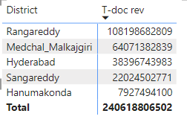

**Task 3 :**

Categorize districts into three segments based on their stamp registration revenue generation during the fiscal year 2021 to 2022.

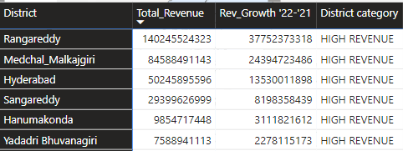

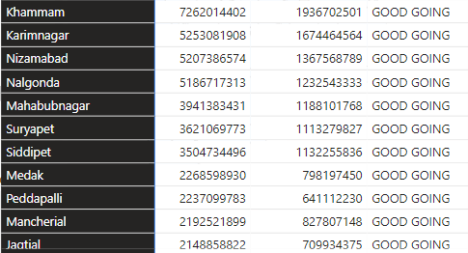

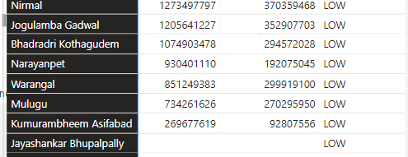

**Task 4 :**

How does the distribution of vehicles vary by vehicle class (MotorCycle, MotorCar, AutoRickshaw, Agriculture) across different districts? Are there any districts with a predominant preference for a specific vehicle class? Consider FY 2022 for analysis.

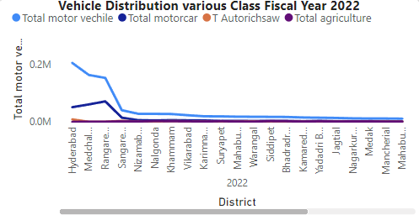

**Task 5 :**

List down the top 3 and bottom 3 districts that have shown the highest and lowest vehicle sales growth during FY 2022 compared to FY 2021? (Consider and compare categories: Petrol, Diesel and Electric

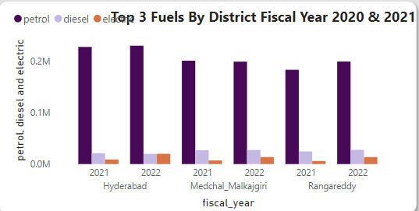

**Task 6 :**

List down the top 5 sectors that have witnessed the most significant investments in FY 2022.

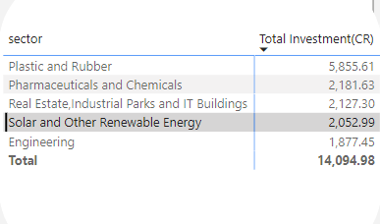

**Task 7 :**

List down the top 3 districts that have attracted the most significant sector investments during FY 2019 to 2022? What factors could have led to the substantial investments in these particular districts?

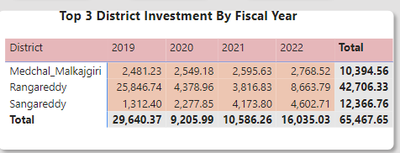

**Task 8 :**

Are there any particular sectors that have shown substantial investment in multiple districts between FY 2021 and 2022?

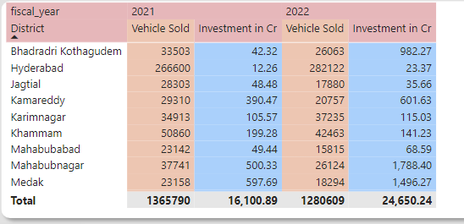

 Special thanks to the codebasics team, @Dhaval Patel sir, and @Hemanand Vadivel sir for collaborating with the Telangana government on this real-time data project.  
  
I extend my gratitude to the Government of Telangana and our respected stakeholders:  
  
-@Kalvakuntla Taraka Rama Rao / @KTR, Minister for IT, Industries, and Municipal Administration  
- @Jayesh Ranjan, Secretary, Information Technology (IT); Government of Telangana  
- @Dileep Konatham, Director at Government of Telangana  
-@venu panjarla, Open Data Consultant  
  
For more project information, please visit these links:  
Dashboard link : <https://app.powerbi.com/view?r=eyJrIjoiNDI1YTgyZTYtNTliNC00ZGY0LTk2YTUtODM3MmY5NTQyNzBmIiwidCI6ImM2ZTU0OWIzLTVmNDUtNDAzMi1hYWU5LWQ0MjQ0ZGM1YjJjNCJ9>

[#CodeBasicsResumeProjectChallenge](https://www.linkedin.com/feed/hashtag/?keywords=codebasicsresumeprojectchallenge&highlightedUpdateUrns=urn%3Ali%3Aactivity%3A7112648825349025793) [#OpenDataTelangana](https://www.linkedin.com/feed/hashtag/?keywords=opendatatelangana&highlightedUpdateUrns=urn%3Ali%3Aactivity%3A7112648825349025793) [#CRPC7](https://www.linkedin.com/feed/hashtag/?keywords=crpc7&highlightedUpdateUrns=urn%3Ali%3Aactivity%3A7112648825349025793) [#GovernmentofTelangana](https://www.linkedin.com/feed/hashtag/?keywords=governmentoftelangana&highlightedUpdateUrns=urn%3Ali%3Aactivity%3A7112648825349025793) [#HappeningHyderabad](https://www.linkedin.com/feed/hashtag/?keywords=happeninghyderabad&highlightedUpdateUrns=urn%3Ali%3Aactivity%3A7112648825349025793) [#TelanganaGrowthAnalysis](https://www.linkedin.com/feed/hashtag/?keywords=telanganagrowthanalysis&highlightedUpdateUrns=urn%3Ali%3Aactivity%3A7112648825349025793)